Chapter 11
Integer Linear Programming

Learning Objectives

1. Be able to recognize the types of situations where integer linear programming problem formulations are desirable.

2. Know the difference between all-integer and mixed integer linear programming problems.

3. Be able to solve small integer linear programs with a graphical solution procedure.

4. Be able to formulate and solve fixed charge, capital budgeting, distribution system, and product design problems as integer linear programs.

5. See how zero-one integer linear variables can be used to handle special situations such as multiple choice, k out of n alternatives, and conditional constraints.

6. Be familiar with the computer solution of MILPs.

7. Understand the following terms:

all-integer mutually exclusive constraint
mixed integer k out of n alternatives constraint
zero-one variables conditional constraint
LP relaxation co-requisite constraint
multiple choice constraint

Solutions:

1. a. This is a mixed integer linear program. Its LP Relaxation is

Max | 30x1 | + | 25x2
s.t.
 | 3x1 | + | 1.5x2 | ≤ | 400
 | 1.5x1 | + | 2x2 | ≤ | 250
 | x1 | + | x2 | ≤ | 150

x1, x2 ≥ 0

b. This is an all-integer linear program. Its LP Relaxation just requires dropping the words "and integer" from the last line.

2. a.

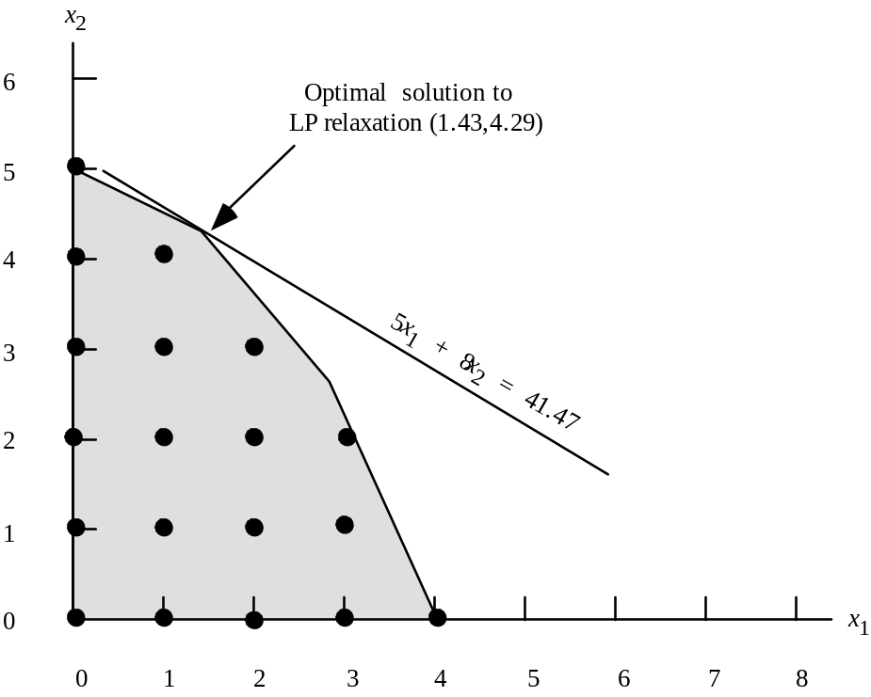

b. The optimal solution to the LP Relaxation is given by x1 = 1.43, x2 = 4.29 with an objective function value of 41.47.

Rounding down gives the feasible integer solution x1 = 1, x2 = 4. Its value is 37.

c.

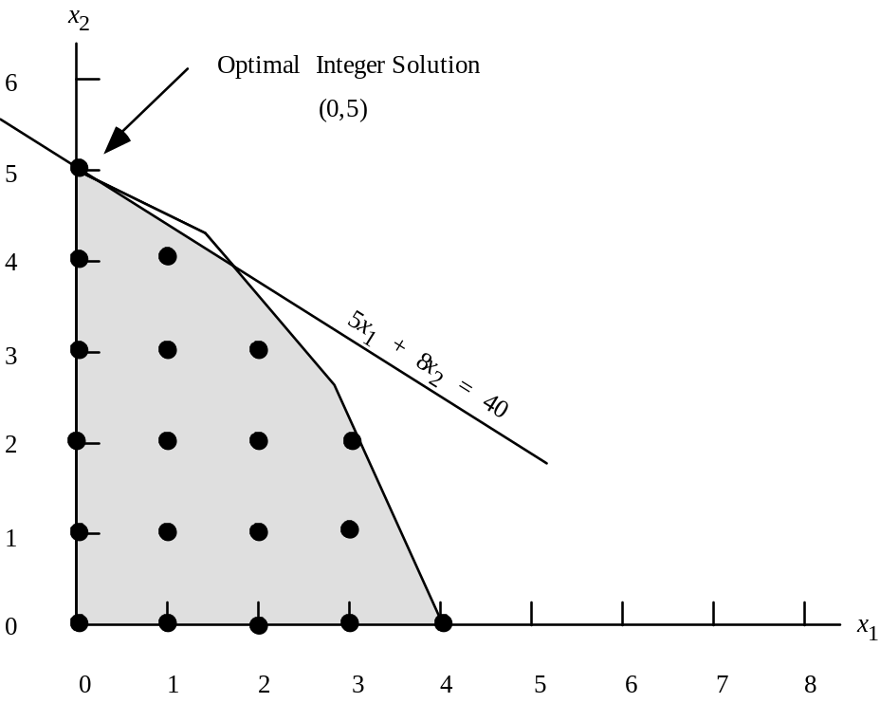
The optimal solution is given by x1 = 0, x2 = 5. Its value is 40. This is not the same solution as that found by rounding down. It provides a 3 unit increase in the value of the objective function.

3. a.

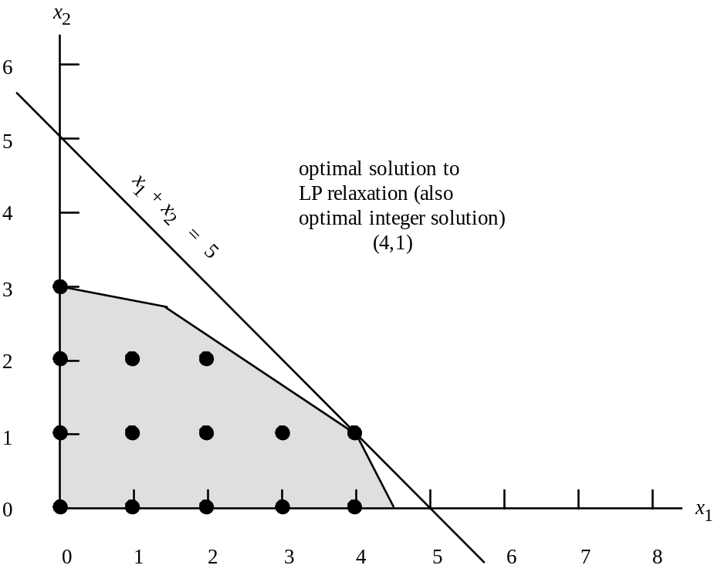
b. The optimal solution to the LP Relaxation is shown on the above graph to be x1 = 4, x2 = 1. Its value is 5.

c. The optimal integer solution is the same as the optimal solution to the LP Relaxation. This is always the case whenever all the variables take on integer values in the optimal solution to the LP Relaxation.

4. a.

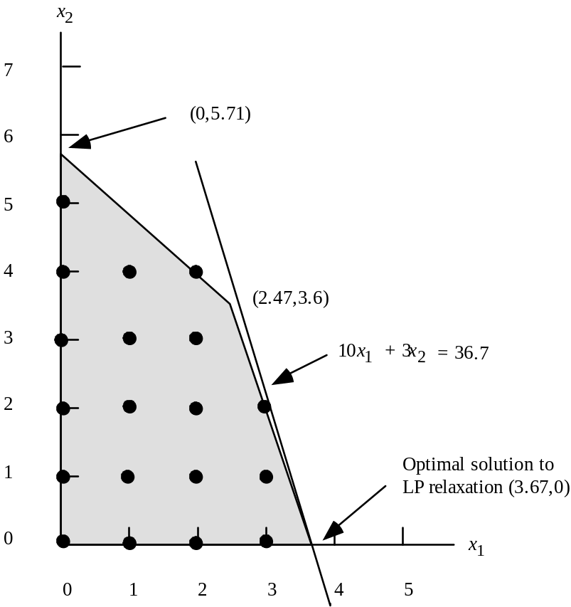

The value of the optimal solution to the LP Relaxation is 36.7 and it is given by x1 = 3.67, x2 = 0.0. Since we have all less-than-or-equal-to constraints with positive coefficients, the solution obtained by "rounding down" the values of the variables in the optimal solution to the LP Relaxation is feasible. The solution obtained by rounding down is x1 = 3, x2 = 0 with value 30.

Thus a lower bound on the value of the optimal solution is given by this feasible integer solution with value 30. An upper bound is given by the value of the LP Relaxation, 36.7. (Actually an upper bound of 36 could be established since no integer solution could have a value between 36 and 37.)

b.
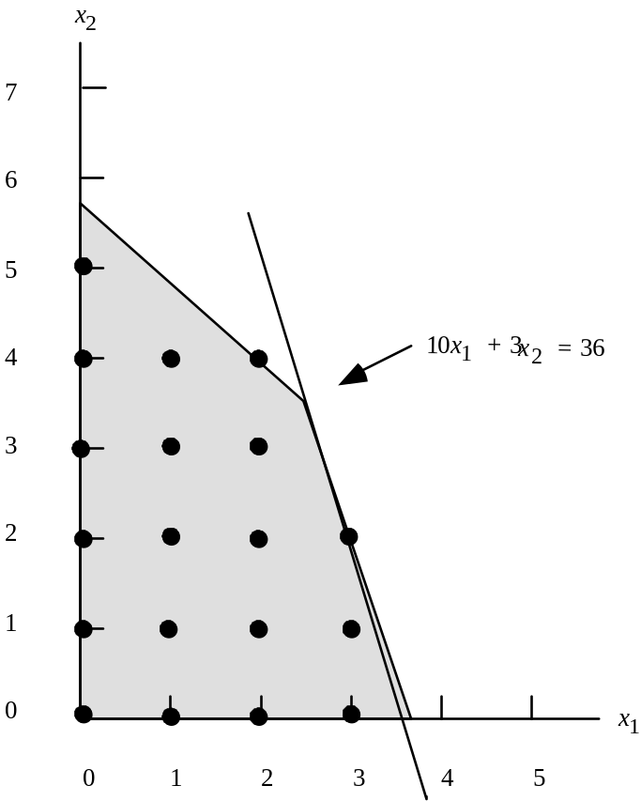

The optimal solution to the ILP is given by x1 = 3, x2 = 2. Its value is 36. The solution found by "rounding down" the solution to the LP relaxation had a value of 30. A 20% increase in this value was obtained by finding the optimal integer solution - a substantial difference if the objective function is being measured in thousands of dollars.
c.
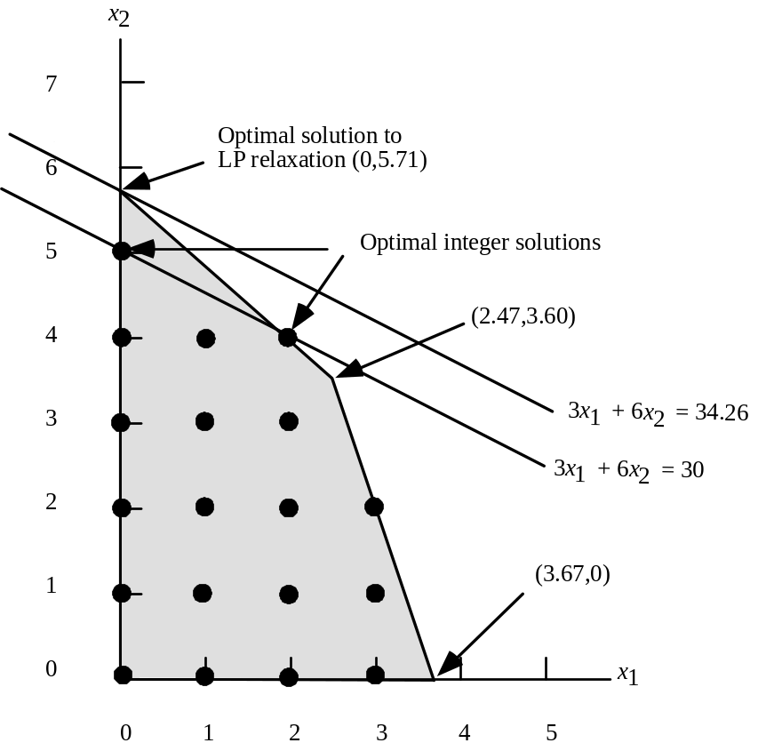
The optimal solution to the LP Relaxation is x1= 0, x2 = 5.71 with value = 34.26. The solution obtained by "rounding down" is x1 = 0, x2 = 5 with value 30. These two values provide an upper bound of 34.26 and a lower bound of 30 on the value of the optimal integer solution.

There are alternative optimal integer solutions given by x1 = 0, x2 = 5 and x1 = 2, x2 = 4; value is 30. In this case rounding the LP solution down does provide the optimal integer solution.

5. a.
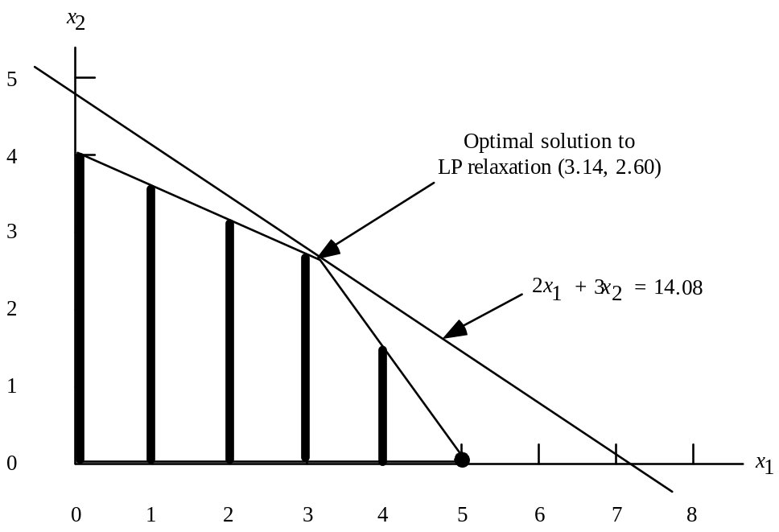

The feasible mixed integer solutions are indicated by the boldface vertical lines in the graph above.

b. The optimal solution to the LP relaxation is given by x1 = 3.14, x2 = 2.60. Its value is 14.08.
Rounding the value of x1 down to find a feasible mixed integer solution yields x1 = 3, x2 = 2.60 with a value of 13.8. This solution is clearly not optimal. With x1 = 3 we can see from the graph that x2 can be made larger without violating the constraints.
c.
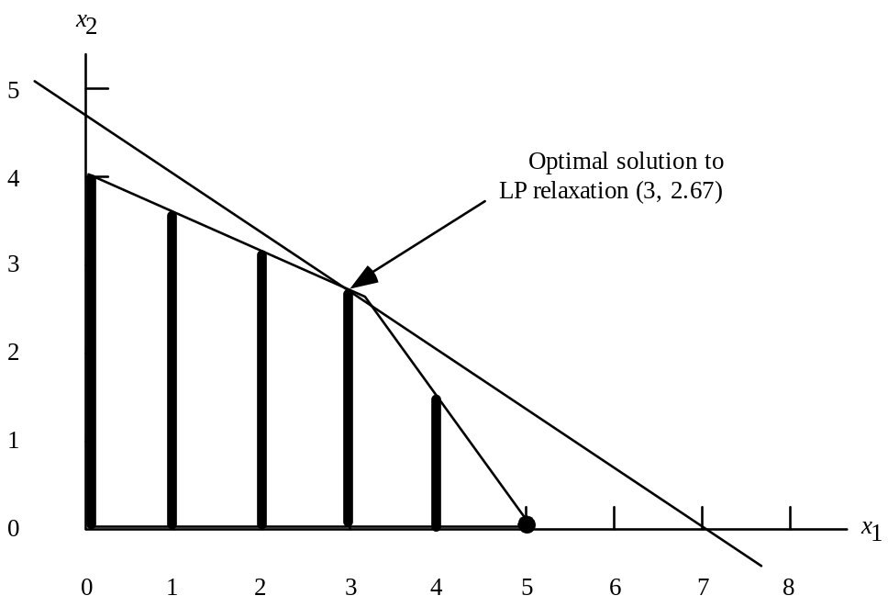
Optimal mixed integer solution (3, 2.67)
The optimal solution to the MILP is given by x1 = 3, x2 = 2.67. Its value is 14.

6. a.

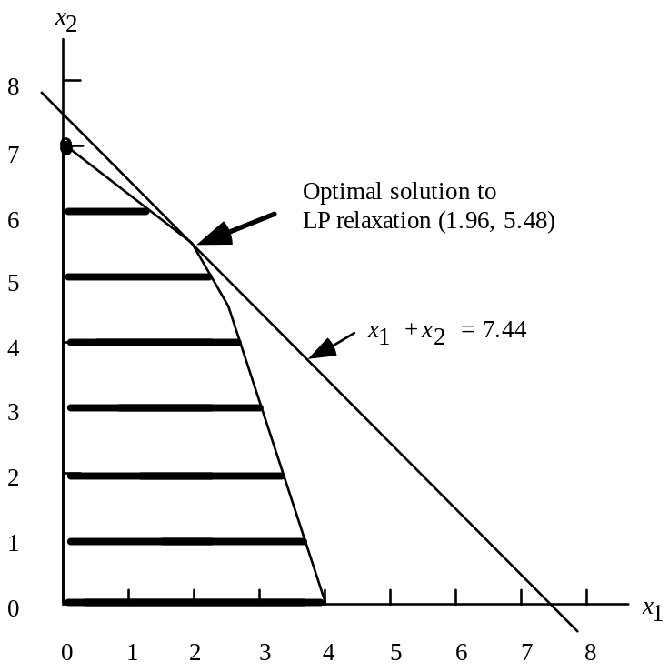

b. The optimal solution to the LP Relaxation is given by x1 = 1.96, x2 = 5.48. Its value is 7.44. Thus an upper bound on the value of the optimal is given by 7.44.

Rounding the value of x2 down yields a feasible solution of x1 = 1.96, x2 = 5 with value 6.96. Thus a lower bound on the value of the optimal solution is given by 6.96.

c.
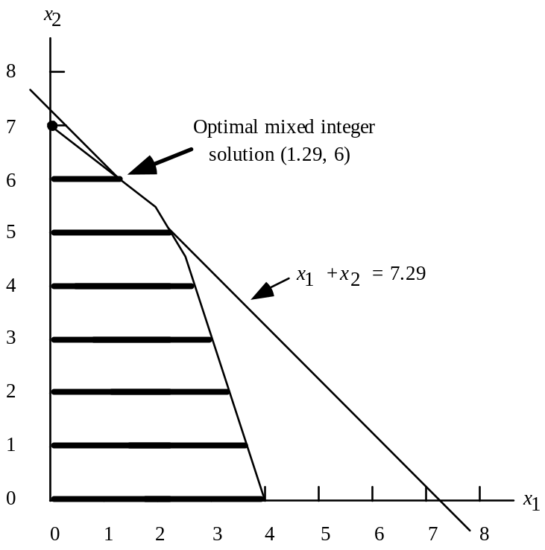

The optimal solution to the MILP is x1 = 1.29, x2 = 6. Its value is 7.29.

The solution x1 = 2.22, x2 = 5 is almost as good. Its value is 7.22.

7. a. x1 + x3 + x5 + x6 = 2

b. x3 - x5 = 0

c. x1 + x4 = 1

d. x4 ≤ x1

x4 ≤ x3

e. x4 ≤ x1

x4 ≤ x3

x4 ≥ x1 + x3 - 1

8. a. Let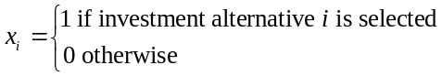

max | 4000x1 | + | 6000x2 | + | 10500x3 | + | 4000x4 | + | 8000x5 | + | 3000x6
s.t.
 | 3000x1 | + | 2500x2 | + | 6000x3 | + | 2000x4 | + | 5000x5 | + | 1000x6 | ≤ | 10,500
 | 1000x1 | + | 3500x2 | + | 4000x3 | + | 1500x4 | + | 1000x5 | + | 500x6 | ≤ | 7,000
 | 4000x1 | + | 3500x2 | + | 5000x3 | + | 1800x4 | + | 4000x5 | + | 900x6 | ≤ | 8,750

x1, x2, x3, x4, x5, x6 = 0, 1

Optimal Solution found:

x3 = 1
x4 = 1
x6 = 1

Value = 17,500

b. The following mutually exclusive constraint must be added to the model.

x1 + x2 ≤ 1 No change in optimal solution.

c. The following co-requisite constraint must be added to the model in b.

x3 - x4 = 0. No change in optimal solution.

9. a. x4 ≤ 8000 s4

b. x6 ≤ 6000 s6

c. x4 ≤ 8000 s4
x6 ≤ 6000 s6
s4 + s6 = 1

d. Min 15 x4 + 18 x6 + 2000 s4 + 3500 s6

10. a. Let xi = 1 if a substation is located at site i, 0 otherwise

min | xA | + | xB | + | xC | + | xD | + | xE | + | xF | + | xG
s.t.
 | xA | + | xB | + | xC |  |  |  |  |  |  | + | xG | ≥ | 1 (area 1 covered)
 |  |  | xB |  |  | + | xD |  |  |  |  |  |  | ≥ | 1 (area 2 covered)
 |  |  |  |  | xC |  |  | + | xE |  |  |  |  | ≥ | 1 (area 3 covered)
 |  |  |  |  |  |  | xD | + | xE | + | xF |  |  | ≥ | 1 (area 4 covered)
 | xA | + | xB | + | xC | + | xD |  |  | + | xF | + | xG | ≥ | 1 (area 5 covered)
 |  |  |  |  |  |  |  |  | xE | + | xF | + | xG | ≥ | 1 (area 6 covered)
 | xA | + | xB |  |  |  |  |  |  |  |  | + | xG | ≥ | 1 (area 7 covered)

b. Choose locations B and E.

11. a. Let Pi = units of product i produced

Max | 25P1 | + | 28P2 | + | 30P3
s.t.
 | 1.5P1 | + | 3P2 | + | 2P3 | ≤ | 450
 | 2P1 | + | 1P2 | + | 2.5P3 | ≤ | 350
 | .25P1 | + | .25P2 | + | .25P3 | ≤ | 50
P1, P2, P3 ≥ 0
b. The optimal solution is

P1 = 60
P2 = 80 Value = 5540
P3 = 60

This solution provides a profit of $5540.

c. Since the solution in part (b) calls for producing all three products, the total setup cost is

$1550 = $400 + $550 + $600.

Subtracting the total setup cost from the profit in part (b), we see that

Profit = $5540 - 1550 = $3990

d. We introduce a 0-1 variable yi that is one if any quantity of product i is produced and zero otherwise.

With the maximum production quantities provided by management, we obtain 3 new constraints:

P1 ≤ 175y1
P2 ≤ 150y2
P3 ≤ 140y3

Bringing the variables to the left-hand side of the constraints, we obtain the following fixed charge formulation of the Hart problem.

Max | 25P1 | + | 28P2 | + | 30P3 | - | 400y1 | - | 550y2 | - | 600y3
s.t.
 | 1.5P1 | + | 3P2 | + | 2P3 |  |  |  |  |  |  | ≤ | 450
 | 2P1 | + | 1P2 | + | 2.5P3 |  |  |  |  |  |  | ≤ | 350
 | .25P1 | + | .25P2 | + | .25P3 |  |  |  |  |  |  | ≤ | 50
 | P1 |  |  |  |  | - | 175y1 |  |  |  |  | ≤ | 0
 |  |  | P2 |  |  |  |  | - | 150y2 |  |  | ≤ | 0
 |  |  |  |  | P3 |  |  |  |  | - | 140y3 | ≤ | 0
P1, P2, P3 ≥ 0; y1, y2, y3 = 0, 1

e. The optimal solution is

P1 = 100 y1 = 1
P2 = 100 y2 = 1 Value = 4350
P3 = 0 y3 = 0

The profit associated with this solution is $4350. This is an improvement of $360 over the solution in part (c).

12.
Part a.

We use the following data:

b_{ij} = the bid for city i from carrier j, i=1,2,…20 j=1,2,…7
dem_{i} = the demand in truckload for city i i=1,2,…20
c_{ij} = the cost of assigning city i to carrier j i=1,2,…20 j=1,2,…7

Note: c_{ij} = (dem_{i})(b_{ij}) used in the objective function.

Let y[j] = 1 if carrier j is selected, 0 if not j=1,2,…7
x[i,j] = 1 if city i is assigned to carrier j, 0 if not i=1,2,…20 j=1,2,…7

Minimize the cost of city-carrier assignments (note: for brevity, zeros are not shown).

Minimize
65640*x[1,5] + 49980*x[1,6] + 53700*x[1,7] + 14530*x[2,2] +
26020*x[2,5] + 17670*x[2,6] + 30680*x[3,2] + 45660*x[3,5] +
37140*x[3,6] + 37400*x[3,7] + 67480*x[4,2] + 104680*x[4,5] +
69520*x[4,6] + 15230*x[5,2] + 22390*x[5,5] + 17710*x[5,6] +
18550*x[5,7] + 15210*x[6,2] + 15710*x[6,5] + 15450*x[6,7] +
25200*x[7,2] + 23064*x[7,4] + 23256*x[7,5] + 24600*x[7,7] +
45000*x[8,2] + 35800*x[8,4] + 35400*x[8,5] + 43475*x[8,7] +
28350*x[9,2] + 30825*x[9,4] + 29525*x[9,5] + 28750*x[9,7] +
22176*x[10,2] + 20130*x[10,4] + 22077*x[10,5] + 22374*x[10,7] +
7964*x[11,1] + 7953*x[11,3] + 6897*x[11,4] + 7227*x[11,5] +
7766*x[11,7] + 22214*x[12,1] + 22214*x[12,3] + 20909*x[12,4] +
19778*x[12,5] + 21257*x[12,7] + 8892*x[13,1] + 8940*x[13,3] +
8184*x[13,5] + 8796*x[13,7] + 19560*x[14,1] + 19200*x[14,2] +
19872*x[14,3] + 17880*x[14,5] + 19968*x[14,7] + 9040*x[15,1] +
8800*x[15,3] + 8910*x[15,5] + 9140*x[15,7] + 9580*x[16,1] +
9330*x[16,3] + 8910*x[16,5] + 9140*x[16,7] + 21275*x[17,1] +
21367*x[17,3] + 21551*x[17,5] + 22632*x[17,7] + 22300*x[18,1] +
21725*x[18,3] + 20550*x[18,4] + 20725*x[18,5] + 21600*x[18,7] +
11124*x[19,1] + 11628*x[19,3] + 11604*x[19,5] + 12096*x[19,7] +
9630*x[20,1] + 9380*x[20,3] + 9550*x[20,5] + 9950*x[20,7]

subject to

Every City is assigned to exactly one carrier:

x[1,1] + x[1,2] + x[1,3] + x[1,4] + x[1,5] + x[1,6] + x[1,7] = 1
x[2,1] + x[2,2] + x[2,3] + x[2,4] + x[2,5] + x[2,6] + x[2,7] = 1
x[3,1] + x[3,2] + x[3,3] + x[3,4] + x[3,5] + x[3,6] + x[3,7] = 1
x[4,1] + x[4,2] + x[4,3] + x[4,4] + x[4,5] + x[4,6] + x[4,7] = 1
x[5,1] + x[5,2] + x[5,3] + x[5,4] + x[5,5] + x[5,6] + x[5,7] = 1
x[6,1] + x[6,2] + x[6,3] + x[6,4] + x[6,5] + x[6,6] + x[6,7] = 1
x[7,1] + x[7,2] + x[7,3] + x[7,4] + x[7,5] + x[7,6] + x[7,7] = 1
x[8,1] + x[8,2] + x[8,3] + x[8,4] + x[8,5] + x[8,6] + x[8,7] = 1
x[9,1] + x[9,2] + x[9,3] + x[9,4] + x[9,5] + x[9,6] + x[9,7] = 1
x[10,1] + x[10,2] + x[10,3] + x[10,4] + x[10,5] + x[10,6] + x[10,7] = 1
x[11,1] + x[11,2] + x[11,3] + x[11,4] + x[11,5] + x[11,6] + x[11,7] = 1
x[12,1] + x[12,2] + x[12,3] + x[12,4] + x[12,5] + x[12,6] + x[12,7] = 1
x[13,1] + x[13,2] + x[13,3] + x[13,4] + x[13,5] + x[13,6] + x[13,7] = 1
x[14,1] + x[14,2] + x[14,3] + x[14,4] + x[14,5] + x[14,6] + x[14,7] = 1
x[15,1] + x[15,2] + x[15,3] + x[15,4] + x[15,5] + x[15,6] + x[15,7] = 1
x[16,1] + x[16,2] + x[16,3] + x[16,4] + x[16,5] + x[16,6] + x[16,7] = 1
x[17,1] + x[17,2] + x[17,3] + x[17,4] + x[17,5] + x[17,6] + x[17,7] = 1
x[18,1] + x[18,2] + x[18,3] + x[18,4] + x[18,5] + x[18,6] + x[18,7] = 1
x[19,1] + x[19,2] + x[19,3] + x[19,4] + x[19,5] + x[19,6] + x[19,7] = 1
x[20,1] + x[20,2] + x[20,3] + x[20,4] + x[20,5] + x[20,6] + x[20,7] = 1

If a Carrier is selected, it can be assigned only the number of bids made:

Note:
The idea here is that if carrier j is not chosen, then no cities can be assigned to that carrier. Hence if y[j] = 0, the sum must be less than or equal to zero and hence all the associated x’s must be zero. If y[j] = 1 then the constraint becomes redundant. It could also be modeled as x[i,j] <= y[j] but this would generate more constraints

x[1,1] + x[2,1] + x[3,1] + x[4,1] + x[5,1] + x[6,1] + x[7,1]+ x[8,1] + x[9,1] + x[10,1] + x[11,1] + x[12,1] + x[13,1] + x[14,1] + x[15,1] + x[16,1] + x[17,1] + x[18,1] + x[19,1] + x[20,1] <= 10*y[1]

x[1,2] + x[2,2] + x[3,2] + x[4,2] + x[5,2] + x[6,2] + x[7,2] + x[8,2] + x[9,2] + x[10,2] + x[11,2] + x[12,2] + x[13,2] + x[14,2] + x[15,2] + x[16,2] + x[17,2] + x[18,2] + x[19,2] + x[20,2] <= 10*y[2]

x[1,3] + x[2,3] + x[3,3] + x[4,3] + x[5,3] + x[6,3] + x[7,3] + x[8,3] + x[9,3] + x[10,3] + x[11,3] + x[12,3] + x[13,3] + x[14,3] + x[15,3] + x[16,3] + x[17,3] + x[18,3] + x[19,3] + x[20,3] <= 10*y[3]

x[1,4] + x[2,4] + x[3,4] + x[4,4] + x[5,4] + x[6,4] + x[7,4]+ x[8,4] + x[9,4] + x[10,4] + x[11,4] + x[12,4] + x[13,4] + x[14,4] + x[15,4] + x[16,4] + x[17,4] + x[18,4] + x[19,4] + x[20,4] <= 7*y[4]

x[1,5] + x[2,5] + x[3,5] + x[4,5] + x[5,5] + x[6,5] + x[7,5] + x[8,5] + x[9,5] + x[10,5] + x[11,5] + x[12,5] + x[13,5] + x[14,5] + x[15,5] + x[16,5] + x[17,5] + x[18,5] + x[19,5] + x[20,5] <= 20*y[5]

x[1,6] + x[2,6] + x[3,6] + x[4,6] + x[5,6] + x[6,6] + x[7,6]+ x[8,6] + x[9,6] + x[10,6] + x[11,6] + x[12,6] + x[13,6] + x[14,6] + x[15,6] + x[16,6] + x[17,6] + x[18,6] + x[19,6] + x[20,6] <= 5*y[6]

x[1,7] + x[2,7] + x[3,7] + x[4,7] + x[5,7] + x[6,7] + x[7,7] + x[8,7] + x[9,7] + x[10,7] + x[11,7] + x[12,7] + x[13,7] + x[14,7] + x[15,7] + x[16,7] + x[17,7] + x[18,7] + x[19,7] + x[20,7] <= 18*y[7]

Non-bids must be set to 0:

x[1,1] + x[2,1] + x[3,1] + x[4,1] + x[5,1] + x[6,1] + x[7,1] + x[8,1]
+ x[9,1] + x[10,1] = 0

x[1,2] + x[11,2] + x[12,2] + x[13,2] + x[15,2] + x[16,2] + x[17,2] +
x[18,2] + x[19,2] + x[20,2] = 0

x[1,3] + x[2,3] + x[3,3] + x[4,3] + x[5,3] + x[6,3] + x[7,3] + x[8,3]
+ x[9,3] + x[10,3] = 0

x[1,4] + x[2,4] + x[3,4] + x[4,4] + x[5,4] + x[6,4] + x[13,4] + x[14,4]
+ x[15,4] + x[16,4] + x[17,4] + x[19,4] + x[20,4] = 0

x[6,6] + x[7,6] + x[8,6] + x[9,6] + x[10,6] + x[11,6] + x[12,6] + x[13,6] + x[14,6] + x[15,6] + x[16,6] + x[17,6] + x[18,6] + x[19,6] + x[20,6] = 0

x[2,7] + x[4,7] = 0

No more than 3 carriers

y[1] + y[2] + y[3] + y[4] + y[5] + y[6] + y[7] <= 3

Solution: Total Cost = $436,512
Carrier 2: assigned cities 2,3,4,5,6, and 9
Carrier 5: assigned cities 7,8,and 10-20
Carrier 6: assigned city 1

Part b.

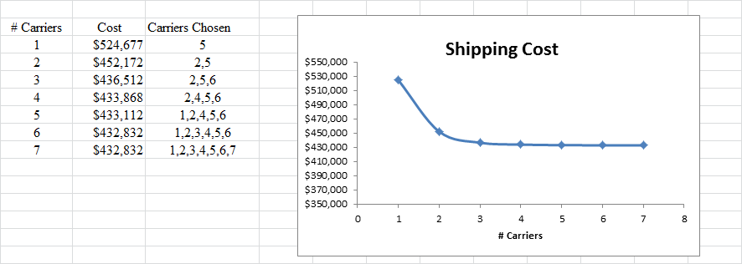

Given the incremental drop in cost, three seems like the correct number of carriers (the curve flattens considerably after three carriers).

13. a. One just needs to add the following multiple choice constraint to the problem.

y1 + y2 = 1

New Optimal Solution: y1 = 1, y3 = 1, x12 = 10, x31 = 30, x52 = 10, x53 = 20

Value = 940

b. Since one plant is already located in St. Louis, it is only necessary to add the following constraint to the model

y3 + y4 ≤ 1

New Optimal Solution: y4 = 1, x42 = 20, x43 = 20, x51 = 30

Value = 860

14. a. Let 1 denote the Michigan plant
2 denote the first New York plant
3 denote the second New York plant
4 denote the Ohio plant
5 denote the California plant

It is not possible to meet needs by modernizing only one plant.

The following table shows the options which involve modernizing two plants.

 |  | Plant |  |  | Transmission | Engine Block
1 | 2 | 3 | 4 | 5 | Capacity | Capacity | Feasible ? | Cost
√ | √ |  |  |  | 700 | 1300 | No
√ |  | √ |  |  | 1100 | 900 | Yes | 60
√ |  |  | √ |  | 900 | 1400 | Yes | 65
√ |  |  |  | √ | 600 | 700 | No
 | √ | √ |  |  | 1200 | 1200 | Yes | 70
 | √ |  | √ |  | 1000 | 1700 | Yes | 75
 | √ |  |  | √ | 700 | 1000 | No
 |  | √ | √ |  | 1400 | 1300 | Yes | 75
 |  | √ |  | √ | 1100 | 600 | No
 |  |  | √ | √ | 900 | 1100 | Yes | 60

b. Modernize plants 1 and 3 or plants 4 and 5.

c. Let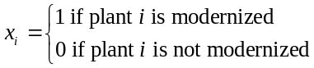

Min | 25x1 | + | 35x2 | + | 35x3 | + | 40x4 | + | 25x5
s.t.
 | 300x1 | + | 400x2 | + | 800x3 | + | 600x4 | + | 300x5 | ≥ | 900 Transmissions
 | 500x1 | + | 800x2 | + | 400x3 | + | 900x4 | + | 200x5 | ≥ | 900 Engine Blocks

d. Optimal Solution: x1 = x3 = 1.

15. a. Let 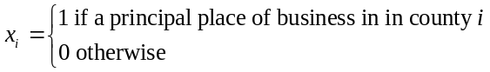

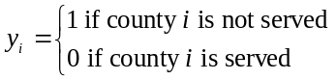

The objective function for an integer programming model calls for minimizing the population not served.

min 195y1 + 96y2 + • • • + 175 y13

There are 13 constraints needed; each is written so that yi will be forced to equal one whenever it is not possible to do business in county i.

Constraint 1: | x1 | + | x2 | + | x3 |  |  |  |  |  |  | + | y1 | ≥ | 1
Constraint 2: | x1 | + | x2 | + | x3 | + | x4 | + | x6 | + | x7 | + | y2 | ≥ | 1
• |  |  |  |  |  |  |  |  | • |  |  |  |  |  | •
• |  |  |  |  |  |  |  |  | • |  |  |  |  |  | •
• |  |  |  |  |  |  |  |  | • |  |  |  |  |  | •
Constraint 13: |  |  | x11 | + | x12 | + | x13 |  |  |  |  | + | y13 | ≥ | 1

One more constraint must be added to reflect the requirement that only one principal place of business may be established.

x1 + x2 + • • • + x13 = 1

The optimal solution has a principal place of business in County 11 with an optimal value of 739,000. A population of 739,000 cannot be served by this solution. Counties 1-5 and 10 will not be served.

b. The only change necessary in the integer programming model for part a is that the right-hand side of the last constraint is increased from 1 to 2.

x1 + x2 + • • • + x13 = 2.

The optimal solution has principal places of business in counties 3 and 11 with an optimal value of 76,000. Only County 10 with a population of 76,000 is not served.

c. It is not the best location if only one principal place of business can be established; 1,058,000 customers in the region cannot be served. However, 642,000 can be served and if there is no opportunity to obtain a principal place of business in County 11, this may be a good start. Perhaps later there will be an opportunity in County 11.

16. a.

min | 105x9 | + | 105x10 | + | 105x11 | + | 32y9 | + | 32y10 | + | 32y11 | + | 32y12 | + | 32y1 | + | 32y2 | + | 32y3
 | x9 |  |  |  |  | + | y9 |  |  |  |  |  |  |  |  |  |  |  |  | ≥ | 6
 | x9 | + | x10 |  |  | + | y9 | + | y10 |  |  |  |  |  |  |  |  |  |  | ≥ | 4
 | x9 | + | x10 | + | x11 | + | y9 | + | y10 | + | y11 |  |  |  |  |  |  |  |  | ≥ | 8
 | x9 | + | x10 | + | x11 | + | y9 | + | y10 | + | y11 | + | y12 |  |  |  |  |  |  | ≥ | 10
 |  |  | x10 | + | x11 |  |  | + | y10 | + | y11 | + | y12 | + | y1 |  |  |  |  | ≥ | 9
 | x9 |  |  |  | x11 |  |  |  |  | + | y11 | + | y12 | + | y1 | + | y2 |  |  | ≥ | 6
 | x9 | + | x10 |  |  |  |  |  |  |  |  | + | y12 | + | y1 | + | y2 | + | y3 | ≥ | 4
 | x9 | + | x10 | + | x11 |  |  |  |  |  |  |  |  | + | y1 | + | y2 | + | y3 | ≥ | 7
 |  |  | x10 | + | x11 |  |  |  |  |  |  |  |  |  |  | + | y2 | + | y3 | ≥ | 6
 |  |  |  |  | x11 |  |  |  |  |  |  |  |  |  |  |  |  | + | y3 | ≥ | 6

xi, yj ≥ 0 and integer for i = 9, 10, 11 and j = 9, 10, 11, 12, 1, 2, 3

b. Solution to LP Relaxation obtained using LINDO/PC:

y9 = 6 y12 = 6 y3 = 6 All other variables = 0.
y11 = 2 y1 = 1 Cost: $672.

c. The solution to the LP Relaxation is integral therefore it is the optimal solution to the integer program.

A difficulty with this solution is that only part-time employees are used; this may cause problems with supervision, etc. The large surpluses from 5, 12-1 (4 employees), and 3-4 (9 employees) indicate times when the tellers are not needed for customer service and may be reassigned to other tasks.

d. Add the following constraints to the formulation in part (a).

x9 ≥ 1
x11 ≥ 1
x9 +x10 + x11 ≥ 5

The new optimal solution, which has a daily cost of $909 is

x9 = 1 y9 = 5
x11 = 4 y12 = 5
y3 = 2

There is now much less reliance on part-time employees. The new solution uses 5 full-time employees and 12 part-time employees; the previous solution used no full-time employees and 21 part-time employees.
17. a. Let x₁ = 1 if PPB is Lorain, 0 otherwise
x₂ = 1 if PPB is Huron, 0 otherwise
x₃ = 1 if PPB is Richland, 0 otherwise
x₄ = 1 if PPB is Ashland, 0 otherwise
x₅ = 1 if PPB is Wayne, 0 otherwise
x₆ = 1 if PPB is Medina, 0 otherwise
x₇ = 1 if PPB is Knox, 0 otherwise

Min | x1 | + | x2 | + | x3 | + | x4 | + | x5 | + | x6 | + | x7
s.t.
 | x1 | + | x2 |  |  | + | x4 |  |  | + | x6 |  |  | ≥ | 1 (Lorain)
 | x1 | + | x2 | + | x3 | + | x4 |  |  |  |  |  |  | ≥ | 1 (Huron)
 |  |  | x2 | + | x3 | + | x4 |  |  |  |  | + | x7 | ≥ | 1 (Richland)
 | x1 | + | x2 | + | x3 | + | x4 | + | x5 | + | x6 | + | x7 | ≥ | 1 (Ashland)
 |  |  |  |  |  |  | x4 | + | x5 | + | x6 |  |  | ≥ | 1 (Wayne)
 | x1 |  |  |  |  | + | x4 | + | x5 | + | x6 |  |  | ≥ | 1 (Medina)
 |  |  |  |  | x3 | + | x4 |  |  |  |  | + | x7 | ≥ | 1 (Knox)

b. Locating a principal place of business in Ashland county will permit Ohio Trust to do business in all 7 counties.

18. a. Add the part-worths for Antonio's Pizza for each consumer in the Salem Foods' consumer panel.

Consumer | Overall Preference for Antonio's
1 | 2 + 6 + 17 + 27 | = 52
2 | 7 + 15 + 26 + 1 | = 49
3 | 5 + 8 + 7 + 16 | = 36
4 | 20 + 20 + 14 + 29 | = 83
5 | 8 + 6 + 20 + 5 | = 39
6 | 17 + 11 + 30 + 12 | = 70
7 | 19 + 12 + 25 + 23 | = 79
8 | 9 + 4 + 16 + 30 | = 59

b. Let l_{ij} = 1 if level i is chosen for attribute j, 0 otherwise
y_{k} = 1 if consumer k chooses the Salem brand, 0 otherwise

Max y₁ + y₂ + y₃ + y₄ + y₅ + y₆ + y₇ + y₈
s.t.
11l₁₁ + | 2l₂₁ + | 6l₁₂ + | 7l₂₂ + | 3l₁₃ + | 17l₂₃ + | 26l₁₄ + | 27l₂₄ + | 8l₃₄ - | 52y₁ | ≥ 1
11l₁₁ + | 7l₂₁ + | 15l₁₂ + | 17l₂₂ + | 16l₁₃ + | 26l₂₃ + | 14l₁₄ + | 1l₂₄ + | 10l₃₄ - | 49y₂ | ≥ 1
7l₁₁ + | 5l₂₁ + | 8l₁₂ + | 14l₂₂ + | 16l₁₃ + | 7l₂₃ + | 29l₁₄ + | 16l₂₄ + | 19l₃₄ - | 36y₃ | ≥ 1
13l₁₁ + | 20l₂₁ + | 20l₁₂ + | 17l₂₂ + | 17l₁₃ + | 14l₂₃ + | 25l₁₄ + | 29l₂₄ + | 10l₃₄ - | 83y₄ | ≥ 1
2l₁₁ + | 8l₂₁ + | 6l₁₂ + | 11l₂₂ + | 30l₁₃ + | 20l₂₃ + | 15l₁₄ + | 5l₂₄ + | 12l₃₄ - | 39y₅ | ≥ 1
12l₁₁ + | 17l₂₁ + | 11l₁₂ + | 9l₂₂ + | 2l₁₃ + | 30l₂₃ + | 22l₁₄ + | 12l₂₄ + | 20l₃₄ - | 70y₆ | ≥ 1
9l₁₁ + | 19l₂₁ + | 12l₁₂ + | 16l₂₂ + | 16l₁₃ + | 25l₂₃ + | 30l₁₄ + | 23l₂₄ + | 19l₃₄ - | 79y₇ | ≥ 1
5l₁₁ + | 9l₂₁ + | 4l₁₂ + | 14l₂₂ + | 23l₁₃ + | 16l₂₃ + | 16l₁₄ + | 30l₂₄ + | 3l₃₄ - | 59y₈ | ≥ 1
l₁₁ + | l₂₁ |  |  |  |  |  |  |  |  | = 1
 |  | l₁₂ + | l₂₂ |  |  |  |  |  |  | = 1
 |  |  |  | l₁₃ + | l₂₃ |  |  |  |  | = 1
 |  |  |  |  |  | l₁₄ + | l₂₄ + | l₃₄ |  | = 1

The optimal solution shows l₂₁ = l₂₂ = l₂₃ = l₂₄ = 1. This calls for a pizza with a thick crust, a cheese blend, a chunky sauce, and medium sausage. With y₁ = y₂ = y₃ = y₅ = y₇ = y₈ = 1, we see that 6 of the 8 people in the consumer panel will prefer this pizza to Antonio's.

19. a. Let l_{ij} = 1 if level i is chosen for attribute j, 0 otherwise
y_{k} = 1 if child k prefers the new cereal design, 0 otherwise

The share of choices problem to solve is given below:

Max y₁ + y₂ + y₃ + y₄ + y₅ + y₆
s.t.
15l₁₁ + | 35l₂₁ + | 30l₁₂ + | 40l₂₂ + | 25l₃₂ + | 15l₁₃ + | 9l₂₃ - | 75y₁ | ≥ 1
30l₁₁ + | 20l₂₁ + | 40l₁₂ + | 35l₂₂ + | 25l₃₂ + | 8l₁₃ + | 11l₂₃ - | 75y₂ | ≥ 1
40l₁₁ + | 25l₂₁ + | 20l₁₂ + | 40l₂₂ + | 10l₃₂ + | 7l₁₃ + | 14l₂₃ - | 75y₃ | ≥ 1
35l₁₁ + | 30l₂₁ + | 25l₁₂ + | 20l₂₂ + | 30l₃₂ + | 15l₁₃ + | 18l₂₃ - | 75y₄ | ≥ 1
25l₁₁ + | 40l₂₁ + | 40l₁₂ + | 20l₂₂ + | 35l₃₂ + | 18l₁₃ + | 14l₂₃ - | 75y₅ | ≥ 1
20l₁₁ + | 25l₂₁ + | 20l₁₂ + | 35l₂₂ + | 30l₃₂ + | 9l₁₃ + | 16l₂₃ - | 75y₆ | ≥ 1
30l₁₁ + | 15l₂₁ + | 25l₁₂ + | 40l₂₂ + | 40l₃₂ + | 20l₁₃ + | 11l₂₃ - | 75y₇ | ≥ 1
l₁₁ + | l₂₁ |  |  |  |  |  |  | = 1
 |  | l₁₂ + | l₂₂ + | l₃₂ |  |  |  | = 1
 |  |  |  |  | l₁₃ + | l₂₃ |  | = 1

The optimal solution obtained using LINDO or Excel shows l₁₁ = l₃₂ = l₁₃ = 1. This indicates that a cereal with a low wheat/corn ratio, artificial sweetener, and no flavor bits will maximize the share of choices.

The optimal solution also has y₄ = y₅ = y₇ = 1 which indicates that children 4, 5, and 7 will prefer this cereal.

b. The coefficients for the y_{i} variable must be changed to -70 in constraints 1-4 and to -80 in constraints 5-7.

The new optimal solution has l₂₁ = l₁₂ = l₂₃ = 1. This is a cereal with a high wheat/corn ratio, a sugar sweetener, and no flavor bits. Four children will prefer this design: 1, 2, 4, and 5.

20. a. Objective function changes to

Min 25x1 + 40x2 + 40x3 + 40x4 + 25x5

b. x4 = x5 = 1; modernize the Ohio and California plants.

c. Add the constraint x2 + x3 = 1

d. x1 = x3 = 1; modernize the Michigan plant and the first New York plant.

21. a. Let 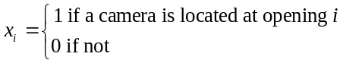

min x1 + x2 + x3 + x4 + x5 + x6 + x7 + x8 + x9 + x10 + x11 + x12 + x13
s.t.
x1 + x4 + x6 ≥ 1 Room 1
x6 + x8 + x12 ≥ 1 Room 2
x1 + x2 + x3 ≥ 1 Room 3
x3 + x4 + x5 + x7 ≥ 1 Room 4
x7 + x8 + x9 + x10 ≥ 1 Room 5
x10 + x12 + x13 ≥ 1 Room 6
x2 + x5 + x9 + x11 ≥ 1 Room 7
x11 + x13 ≥ 1 Room 8

b. x1 = x5 = x8 = x13 = 1. Thus, cameras should be located at 4 openings: 1, 5, 8, and 13.
An alternative optimal solution is x1 = x7 = x11 = x12 = 1.

c. Change the constraint for room 7 to x2 + x5 + x9 + x11 ≥ 2

d. x3 = x6 = x9 = x11 = x12 = 1. Thus, cameras should be located at openings 3, 6, 9, 11, and 12.

An alternate optimal solution is x2 = x4 = x6 = x10 = x11 = 1. Optimal Value = 5

22. Note that Team Size = x1 + x2 + x3

The following two constraints will guarantee that the team size will be 3, 5, or 7.

x1 + x2 + x3 = 3y1 + 5y2 + 7y3
y1 + y2 + y3 = 1

Of course, the variables in the first constraint will need to be brought to the left hand side if a computer solution is desired.

23. a. A mixed integer linear program can be set up to solve this problem. Binary variables are used to indicate whether or not we setup to produce the subassemblies.

Let SB = 1 if bases are produced; 0 if not
STVC = 1 if TV cartridges are produced; 0 if not
SDVDC = 1 if DVD cartridges are produced; 0 if not
STVP = 1 if TV keypads are produced; 0 if not
SDVDP = 1 if DVD keypads are produced; 0 if not
BM = No. of bases manufactured
BP = No. of bases purchased
TVCM = No. of TV cartridges made
•
•
•
DVD PP = No. of DVD keypads purchased

A mixed integer linear programming model for solving this problem follows. There are 11 constraints. Constraints (1) to (5) are to satisfy demand. Constraint (6) reflects the limitation on manufacturing time. Finally, constraints (7) - (11) are constraints not allowing production unless the setup variable equals 1. Variables SB, STVC, SVDVD, STVP, and SDVDP must be specified as 0/1.

LINEAR PROGRAMMING PROBLEM

MIN 0.4BM+2.9TVCM+3.15DVDCM+0.3TVPM+0.55DVDPM+0.65BP+3.45TVCP+3.7DVDCP+0.5TVPP+0
.7DVDPP+1000SB+1200STVC+1900SDVDC+1500STVP+1500SDVDP

S.T.

1) 1BM+1BP=12000
2) +1TVCM+1TVCP=7000
3) +1DVDCM+1DVDCP=5000
4) +1TVPM+1TVPP=7000
5) +1DVDPM+1DVDPP=5000
6) 0.9BM+2.2TVCM+3DVDCM+0.8TVPM+1DVDPM<30000
7) 1BM-12000SB<0
8) +1TVCM-7000STVC<0
9) +1DVDCM-5000SDVDC<0
10) +1TVPM-7000STVP<0
11) +1DVDPM-5000SDVDP<0

OPTIMAL SOLUTION

Objective Function Value = 52800.00

Variable Value
-------------- ---------------
BM 12000.000
TVCM 7000.000
DVDCM 0.000
TVPM 0.000
DVDPM 0.000
BP 0.000
TVCP 0.000
DVDCP 5000.000
TVPP 7000.000
DVDPP 5000.000
SB 1.000
STVC 1.000
SDVDC 0.000
STVP 0.000
SDVDP 0.000

Constraint Slack/Surplus
-------------- ---------------
1 0.000
2 0.000
3 0.000
4 0.000
5 0.000
6 3800.000
7 0.000
8 0.000
9 0.000
10 0.000
11 0.000
b. This part can be solved by changing appropriate coefficients in the formulation for part (a). The coefficient of SDVDC becomes 3000 and the coefficient of DVDCM becomes 2.6 in the objective function. Also, the coefficient of DVDCM becomes 2.5 in constraint (6). The new optimal solution is shown below.

OPTIMAL SOLUTION

Objective Function Value = 52300.00

Variable Value
-------------- ---------------
BM 0.000
TVCM 7000.000
DVDCM 5000.000
TVPM 0.000
DVDPM 0.000
BP 12000.000
TVCP 0.000
DVDCP 0.000
TVPP 7000.000
DVDPP 5000.000
SB 0.000
STVC 1.000
SDVDC 1.000
STVP 0.000
SDVDP 0.000

Constraint Slack/Surplus
-------------- ---------------
1 0.000
2 0.000
3 0.000
4 0.000
5 0.000
6 2100.000
7 0.000
8 0.000
9 0.000
10 0.000
11 0.000

24. a. Variable for movie 1: x111, x112, x121

b. Only 1 schedule for movie 1: x111 + x112 + x121 ≤ 1

c. Only 1 schedule for movie 5: x531 + x532 + x533 + x541 + x542 + x543 + x551 + x552 + x561 ≤ 1

d. Only 2-screens are available at the theater.

Week 1 constraint: x111 + x112 + x211 + x212 + x311 ≤ 2

e. Week 3 constraint:

x213 + x222 + x231 + x422 + x431 + x531 + x532 + x533 + x631 + x632 + x633 ≤ 2

25. a. Let 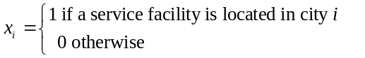

min | x1 | + x2 | + x3 | + x4 | + x5 | + x6 | + x7 | + x8 | + x9 | + x10 | + x11 | + x12
s.t. |  |  |  |  |  |  |  |  |  |  |  |  | 1
(Boston) | x1 | + x2 | + x3 |  |  |  |  |  |  |  |  |  | 1
(New York) | x1 | + x2 | + x3 | + x4 | + x5 | + x6 |  |  |  |  |  |  | 1
(Philadelphia) | x1 | + x2 | + x3 | + x4 | + x5 | + x6 | + x7 |  |  |  |  |  | 1
(Baltimore) |  | x2 | + x3 | + x4 | + x5 | + x6 | + x7 |  |  |  |  |  | 1
(Washington) |  | x2 | + x3 | + x4 | + x5 | + x6 | + x7 |  |  |  |  |  | 1
(Richmond) |  | x2 | + x3 | + x4 | + x5 | + x6 | + x7 | + x8 |  |  |  |  | 1
(Raleigh) |  |  | x3 | + x4 | + x5 | + x6 | + x7 | + x8 | + x9 |  |  |  | 1
(Florence) |  |  |  |  |  | x6 | + x7 | + x8 | + x9 | + x10 |  |  | 1
(Savannah) |  |  |  |  |  |  | x7 | + x8 | + x9 | + x10 | + x11 |  | 1
(Jacksonville) |  |  |  |  |  |  |  | x8 | + x9 | + x10 | + x11 |  | 1
(Tampa) |  |  |  |  |  |  |  |  | x9 | + x10 | + x11 | + x12 | 1
(Miami) |  |  |  |  |  |  |  |  |  |  | x11 | + x12 | 1
x_{i} = 0, 1

b. 3 service facilities: Philadelphia, Savannah and Tampa.

Note: alternate optimal solution is New York, Richmond and Tampa.

c. 4 service facilities: New York, Baltimore, Savannah and Tampa.

Note: alternate optimal solution: Boston, Philadelphia, Florence and Tampa.

26. Let Xi = the amount (dollars) to invest in alternative i i=1,2,…10
Yi = 1 if Dave invests in alternative i, 0 if not i = 1,2…10

Max .067X1 + .0765X2 + .0755X3 + .0745X4 + .075X5 + .0645X6 +
.0705X7 + .069X8 + .052X9 + .059X10

Subject to

X1 + X2 + X3 + X4 + X5 + X6 + X7 + X8 + X9 + X10 = 100,000

Invest $100,000
Xi ≤ 25,000Yi i=1,2,..10
Invest no more than $25,000 in any one fund
Xi ≥ 10,000Yi i=1,2,..10
If invest in a fund, invest at least $10,000 in a fund
Y1 + Y2 + Y3 + Y4 ≤ 2
No more than 2 pure growth funds
Y9 + Y10 ≥ 1
At least 1 must be a pure bond fund
X9 + X10 ≥ X1 + X2 + X3 + X4

Amount in pure bonds must be at least that invested in pure growth funds

Xi ≥ 0 i=1,2,..10

The optimal solution:
